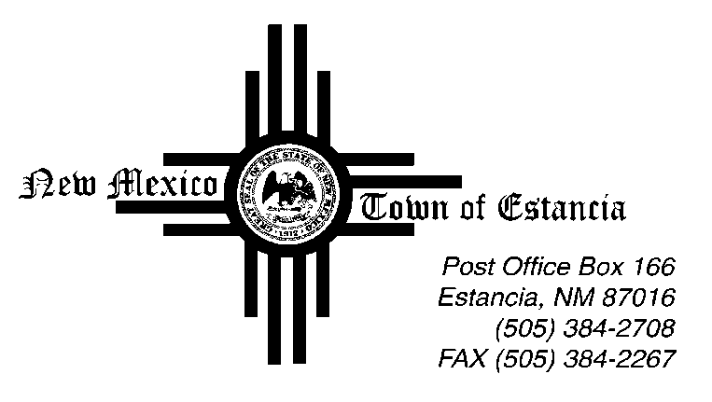

Mayor
Nathan Dial

Mayor Pro Tem
Noah Sedillo

Trustees
Morrow Hall
Stella Chavez
Albert Lovato

____________________________________________________________________________________________

Notice of Possible Quorum

03.02.2022

This Public Notice is being posted to inform the public that there will be a Possible Quorum of some Board of Trustees on Tuesday, March 2, 2022 at Town Hall.

The Possible Quorum will be strictly for the purpose of attending an ‘End of Session Wrap Up’ with Representative Stefani Lord. No action will be taken, and no further business will be conducted.

